Bloomberg Desktop API:  
Installation Instructions for Python  
(versions 2.7, 3.5, and 3.6)

Step 1:   
Download the Software Development Kit (SDK) from WAPI<GO> on the terminal.

Please run the function **WAPI<GO>** on the terminal and click on the link **‘API Download Center’** and then click on the **'Download'** button next to the **'Desktop API'** product. This will download the Software Developer Kit (SDK), which is just a .zip file that you can to extract to ANY directory/location on your PC. This .zip file contains sub-folders for each of the different programming languages we support, but it also contains the corresponding API libraries which allow you to use the objects and methods for each programming language. The Python API relies on our C++ API libraries, included in this SDK.

Step 2:   
Download the wheel installer file corresponding to the specific version of Python you have.

Please click on the hyperlink from the table below for the specific version of Python you have. Use Ctrl + Click to open the link.

|  |  |
| --- | --- |
| **For 32-Bit Python** | **For 64-Bit Python** |
| [Python 2.7 32-Bit - wheel installer](https://bintray.com/bloomberg/BLPAPI-Experimental-pip/download_file?file_path=simple%2Fblpapi%2Fblpapi-3.9.1-cp27-cp27m-win32.whl) | [Python 2.7 64-Bit - wheel installer](https://bintray.com/bloomberg/BLPAPI-Experimental-pip/download_file?file_path=simple%2Fblpapi%2Fblpapi-3.9.1-cp27-cp27m-win_amd64.whl) |
| [Python 3.5 32-Bit - wheel installer](https://bintray.com/bloomberg/BLPAPI-Experimental-pip/download_file?file_path=simple%2Fblpapi%2Fblpapi-3.9.1-cp35-cp35m-win32.whl) | [Python 3.5 64-Bit - wheel installer](https://bintray.com/bloomberg/BLPAPI-Experimental-pip/download_file?file_path=simple%2Fblpapi%2Fblpapi-3.9.1-cp35-cp35m-win_amd64.whl) |
| [Python 3.6 32-Bit - wheel installer](https://bintray.com/bloomberg/BLPAPI-Experimental-pip/download_file?file_path=simple%2Fblpapi%2Fblpapi-3.9.1-cp36-cp36m-win32.whl) | [Python 3.6 64-Bit - wheel installer](https://bintray.com/bloomberg/BLPAPI-Experimental-pip/download_file?file_path=simple%2Fblpapi%2Fblpapi-3.9.1-cp36-cp36m-win_amd64.whl) |

Step 3:   
Open a command prompt and run ‘pip install <filepath>’

Please open a command prompt in Windows by searching for “cmd” from the search box under the Start menu. Run the command pip install followed by the full file path of the wheel installer you downloaded.

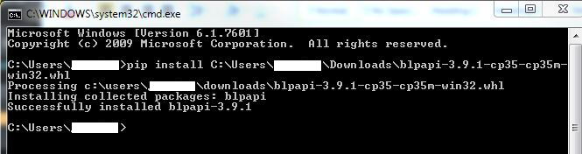

**Note:** If you have Anaconda then please open the Anaconda prompt (instead of the cmd prompt) and then run the pip install command from that Anaconda prompt.